Large tidal volume vs Low tidal volume for prolonged General Anaesthesia
Dr. Raj Sahajanandan MD, DNB, FRCA, Dr.Varsha AV.DA, MD, PDCC (cardiac), Dr. Merlin Shanti Ruth MD
Christian Medical College Vellore.
Introduction
Anaesthesiologists have to deal with heterogeneous patient group intraoperatively with regard to their pulmonary function, surgical procedure and requirement of one lung ventilation. Postoperative respiratory complications are the second most cause of perioperative morbidity after wound infections¹. It is one of the most important factor associated with poor patient outcome, prolonged hospital stay, higher cost and increased 30 day mortality^{1,2}.An open lung strategy with lower tidal volume and an optimal PEEP has been widely accepted in patients with ARDS and critically ill patients in ICU requiring prolonged mechanical ventilation³. Benificial effect of these lung protective strategies in the intraoperative setting where most patients have a normal lung is questionable.
Atelectasis and general anaesthesia
Anaesthesia causes respiratory impairment. Loss of muscle tone causes a fall in the functional residual capacity. This fall promotes airway closure and gas absorption, leading eventually to atelectasis. Atelectasis is due to 3 basic mechanisms:
- Compression atelectasis caused by chest geometry and diaphragm position and motion.^{3,4,5}
- Absorption atelectasis occurs when oxygen is absorbed from alveoli distal to complete airway occlusion, V/Q is low or high FiO₂ is used.⁶
- Loss of surfactant: Atelectasis, once formed due to effects of general anaesthesia, impedes surfactant function so that such a region is prone to collapse again after having been reopened.⁷

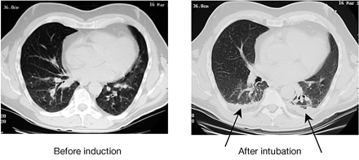
Fig 1Examples of CT scans of a patient with healthy lungs, before and after induction of anaesthesia. The CT slices are 1 cm above the level of the right diaphragm. Arrows indicate lung densities, thought to represent atelectasis (Rusca and colleagues⁸).

Factors which promote atelectasis include Trendelenburg position during surgery, laparoscopic surgery and obesity.

Role of atelectasis in postoperative pulmonary complications:

Major perioperative pulmonary complications include hypoxemia, pneumonia, ventilator induced lung injury, local inflammatory response and requirement for prolonged post operative ventilation. Atelectasis has been implicated as a major cause of the post operative pulmonary complications.

Hypoxemia:
Abnormalities of gas exchange in the perioperative period range from a slight decrement in PaO₂ to life threatening hypoxemia. Atelectasis results in V/Q mismatching due to either pulmonary shunt or dead space. Deleterious effects of atelectasis-related hypoxemia include delirium, wound infection, tachycardia and myocardial ischemia.

Pneumonia:
There is impaired alveolar macrophage activity with atelectasis and loss of surfactant activity which promotes bacterial growth, systemic bacterial translocation and pneumonia. Around 36% of patients with the radiographically diagnosed segmental or lobar atelectasis developed postoperative pneumonia.
Local inflammatory response:
Potential mechanisms by which atelectasis can induce lung injury include overexpansion of adjacent well aerated areas (which may be combined with hyperoxia), mechanical stresses in atelectatic areas, and tissue hypoxia in atelectatic areas. Hyperoxia and hyperinflation lead to an increase in pulmonary proinflammatory cytokines, reactive oxygen species and to excessive leukocyte infiltration. At the same time, atelectasis causes local hypoxia and mechanical stresses which may promote a mild lung injury.It was postulated that the lung injury caused by atelectasis was independent of the stresses caused by mechanical ventilation as it can be reversed when increasing FiO₂ and/or removing atelectasis by lung recruitment⁶.
Since most of atelectasis appearing during general anaesthesia resolves within 24 hrs after surgery⁹ one may argue that there is no need to prevent or study atelectasis since it may have no long‐lasting effects. Nevertheless, patients do develop perioperative respiratory complications and atelectasis is an important factor implicated in their pathogenesis. Prevention of atelectasis is therefore important.¹⁰
Mechanical ventilation and lung injury
Mechanical ventilation during general anaesthesia can lead to lung injury via a number of different mechanisms including volutrauma (repeated overdistention of aerated lung), atelectrauma (cyclic recruitment and derecruitment of lung units) and barotrauma (caused by application of high plateau pressures)¹¹.These deleterious effects are mediated by localised inflammation and release of inflammatory cytokines (biotrauma). Biotrauma not only leads to lung injury but also remote organ dysfunction¹².
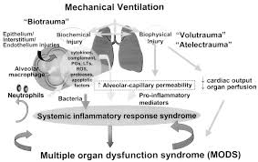

Fig 2: Postulated mechanisms whereby volutrauma, atelectrauma, and biotrauma caused by mechanical ventilation contribute to multiple organ dysfunction syndrome (MODS). The potential importance of biotrauma is not only that it can aggravate ongoing lung injury, but also that it can contribute to the development of MODS, possibly through the release of proinflammatory mediators from the lung

High Tidal Volume ventilation in General anaesthesia

Historically, high tidal volume mechanical ventilation (10-15 ml/kg) has been encouraged for anaesthetized patients intra-operatively for thoracic and abdominal procedures. This has been based on the study published in NEJM in 1963 by Bendixenet al¹³. It followed a series of 18 patients undergoing laparotomy and showed that higher tidal volume resulted in less atelectasis, less acidosis and improved oxygenation compared to lower tidal volumes. However, over the last 2 decades, laboratory and clinical studies have linked higher tidal volumes and higher inflation pressure to a greater degree of lung injury. Most of these studies have been done on patients with acute respiratory distress syndrome and in mechanically ventilated patients in the ICU. Much literature is lacking in the setting of intraoperative ventilation in patients undergoing general anaesthesia.

Low tidal ventilation - Physiological rationale:
The concept of lung protective ventilation was popularized by the landmark ARDS-net study published in 2000 showing lower VT (6-8ml/kg)improved survival in ventilated critically ill patients with ARDS¹⁴. This finding raised the question of beneficial effect of low VT for intra-operative patients with uninjured lung.
Animal studies of VILI have demonstrated high tidal volume ventilation alone, without any preceding insult, can also induce VILI¹⁵. Majority of these studies used relatively short periods of ventilation, resembling the clinical conditions of the operating room. These findings suggest that the use of high tidal volume for ventilation during surgery may be harmful. Furthermore, it can be surmised that the potential harmful effects of ventilation may be minimized by the use of lower VT that cause less lung distension, coupled with optimal PEEP and recruitment manouvers to maintain lung volume.

Clinical evidence:

Abdominal surgery

The initial studies on low tidal volume ventilation in intraoperative setting suggested that low tidal volume ventilation does not have a role in patients without lung injury¹⁶⁻²⁰. However these studies did show feasibility of low tidal ventilation during general anaesthesia for open abdominal surgeries without any adverse effects. In contrast to the previous studies, Severgnini et al, comparing a lung protective mechanical ventilation consisting of tidal volume of 7 ml/kg ideal body weight with PEEP levels of 10 cm H₂O and recruitment manoeuvres versus a tidal volume of 9 ml/kg without PEEP, showed beneficial effects of the lung protective strategy during general anaesthesia lasting more than 2 hours²¹. This strategy improved respiratory function (dynamic spirometry, oxygenation) and reduced pulmonary complications (for upto 5 days) without increasing the incidence of intra-operative complications. The group which received lung protective ventilation had a shorter postoperative hospital stay compared to the control group. Another multicentre randomised trial comparing lung protective ventilation with tidal volume 6-8 ml/ kg of predicted body weight with PEEP of 6-8 cm H₂O and repeated recruitment manoeuvres at 30 minute interval compared with non-protective ventilation (tidal volume 10-12 ml/kg, no PEEP) showed significantly reduced major pulmonary, extra pulmonary complications, postoperative hospital stay and reduced need for postoperative ventilator assistance²². These studies were important considering the large number of enrolled patients, homogeneity of the selected population and the outcome measures included. A large multicentre RCT, the PROVHILO study using lung protective ventilation (tidal volume < 8 ml/kg, PEEP 12 cm of H₂O with recruitment manoeuvres) found that
Intra-operative protective ventilation strategy should include a low tidal volume and low positive end-expiratory pressure, without recruitment manoeuvres²³.

Thoracic surgery
One lung ventilation during thoracic surgery could increase the risk of promoting ventilator induced lung injury because of greater reduction in lung volume and alveolar collapse in the dependent lungs. Schilling et al compared mechanical ventilation with lower tidal volumes (5 ml/kg compared with 10 ml/kg) in open thoracic surgery undergoing one-lung ventilation had significantly decreased pulmonary inflammatory responses²⁴. There was decreased incidence of atelectasis, postoperative acute lung injury, duration of ICU and hospital stay in the low tidal volume group (<8 ml/kg) in a study reported by Licker et al during lung cancer resection surgery²⁵.These observations were subsequently confirmed in a randomised study in patients undergoing elective lobectomy²⁶.Michelet et al reported lesser alterations in lung functions and reduced inflammatory responses with lung protective ventilation (two lung ventilation- 9 ml/kg tidal volume and one lung ventilation- 5 ml/kg with PEEP of 5 cm H₂O)²⁷. Overall, there is a favourable trend based on low tidal volumes, moderate-high PEEP and recruitment manoeuvres during thoracic surgery.

A mild to severe systemic inflammatory response can occur in 10-35% of patients undergoing cardiac surgery. This can induce a reversible acute lung injury. This occurs due to activation of the complement cascade and proinflammatory cytokines during contact of blood products with artificial surfaces and ischemia-reperfusion of the heart and lungs. Injurious mechanical ventilation could aggravate the primary inflammatory response suggestive of a ‘double-hit” hypothesis. There has been an increased interest in protective lung strategies during cardiac surgery. Wrigge et al demonstrated higher levels of TNF-alpha after 6 hour of ventilation with high tidal volume (12 ml/kg)²⁸. A significantly reduced inflammatory response was observed with a moderate PEEP strategy compared to low PEEP, high tidal volume ventilation²⁹.

Cardiac surgery
Reis et al. compared two low tidal ventilation strategies for cardiac surgery immediately after intubation and at the end of CPB(VT 4-6 ml/kg and 10 PEEP Vs VT 6-8 ml/kg and 5 PEEP)^{30,31}.Both strategies showed reduced inflammatory cytokines after CPB. Also early open lung approach significantly attenuated reduction in postoperative FRC and hypoxemia after extubation. Chaney et al. reported better static and dynamic lung compliance and less shunt in patients ventilated with low VT of 6 ml/kg compared to VT 10 ml/kg with similar PEEP³².Sunder and colleagues observed early extubation and lesser rate of re-intubation after cardiac surgery when ventilated with low VT (6ml/kg) compared to high VT( 10 ml/kg)³³.
Most of these studies varied in the size of VT, PEEP and use of recruitment manoeuvre.
However, a recent individual patient meta-analysis suggested that benefit from lung-protection was best explained from VT reductions and not from higher level of PEEP³⁴.While it is important to acknowledge that using low VT without PEEP promotes atelectasis, the optimal PEEP for low VT ventilation remains unclear. PROVHILO study has demonstrated no benefit but increased incidence of hypotension and use of vasopressors with the use of high PEEP. However the optimal PEEP and benefit of recruitment manoeuvre still remains unclear.

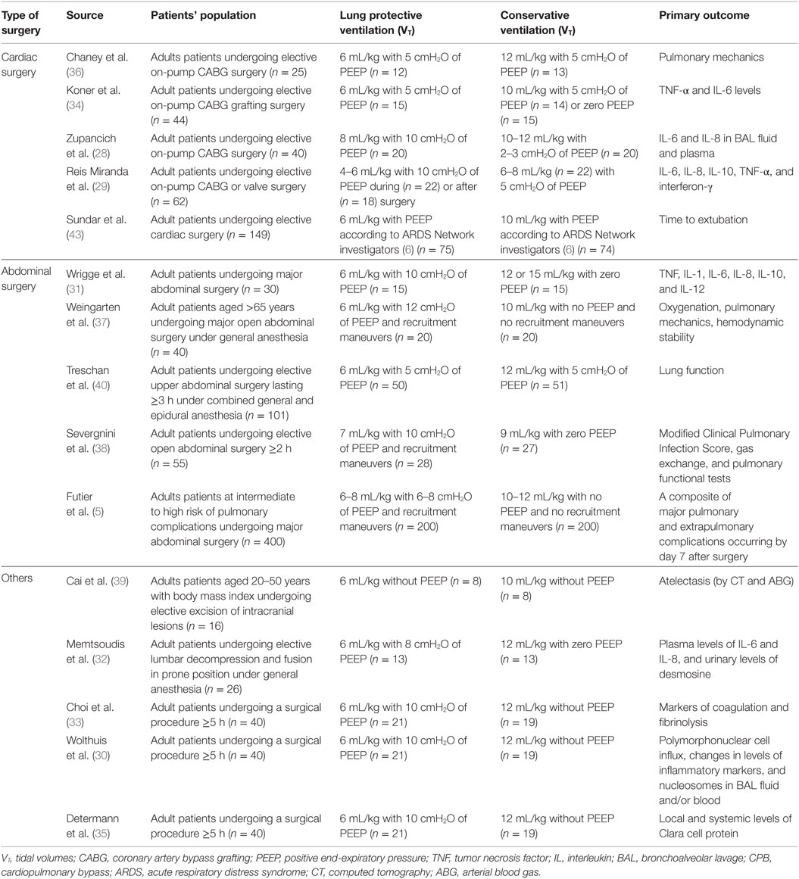

Current Practice and future:
Low tidal volume is increasingly being used as suggested by a recent report on intraoperative ventilation practices in 5 large university hospitals in US³⁵.The study showed a use of median tidal volume of < 8ml/kg in 60% cases after 2013 compared to < 25% prior to 2005.However it is important to consider that use of low tidal ventilation can promote atelectasis in some patients³⁶.Yang et al in their latest meta-analysis have found that intraoperative low tidal ventilation in conjunction with PEEP and intermittent recruitment manoeuvers is associated with significantly improved clinical pulmonary outcomes and reduction in length of hospital stay in otherwise healthy patients undergoing general surgery⁴⁰.Since a reduction in lung stress during mechanical ventilation is the mechanistic explanation for the beneficial effects of lower tidal volumes, the selection of lung protective ventilation should likely be individualized. When employing low tidal volume ventilation, clinicians should consider the type and duration of procedure, pre-existing lung compliance, and the presence of pulmonary disease.
Going forward, a number of questions regarding the specifics of intraoperative lung protective ventilation remain unanswered including the optimal levels of driving pressure, the benefits of lung recruitment manoeuvers, and selection of optimal levels of PEEP. Fortunately, a number of randomized control trials are underway to better characterize methods of lung protection in specialized population³⁷⁻³⁹.Future studies should test the feasibility of brief intraoperative “best PEEP trials” to analyze the effects of PEEP on compliance to select a preventive PEEP level during surgery for the individual patient. To minimize mechanical strain, a combination of lower tidal volume and individualized PEEP seems to be more beneficial compared with the effects of lower tidal volume at zero PEEP or high PEEP with high tidal volume. Additional research is required to define for subgroups of patients based on disease entity, surgical procedure, and anaesthesia plan, the best starting point PEEP to be selected following induction of anaesthesia

References:
- Khuri SF, Henderson WG, DePalma RG, Mosca C, Healey NA, Kumbhani DJ, et al. Determinants of long-term survival after major surgery and the adverse effect of postoperative complications. Ann Surg 2005;242:323-6
- Smetana GW. Postoperative pulmonary complications: an update on risk assessment and reduction. Cleve Clin J Med 2009;76(Suppl 4):S60-5
- Krayer S, Rehder K, Vettermann J, Didier EP, Ritman EL. Position and motion of the human diaphragm during anesthesia‐paralysis. Anesthesiology 1989; 70:891–8
- Warner DO, Warner MA, Ritman EL. Atelectasis and chest wall shape during halothane anesthesia.
- Reber A, Nylund U, Hedenstierna G. Position and shape of the diaphragm: implications for atelectasis formation. Anaesthesia 1998; 53: 1054–6
- Duggan M, Kavanagh BP: Pulmonary atelectasis: a pathogenic perioperative entity. Anesthesiology 2005, 102:838–854.
- Otis DR Jr., Johnson M, Pedley TJ, Kamm RD: Role of pulmonary surfactant in airway closure: a computational study. J ApplPhysiol 1993, 75:1323–1333.
- Rusca M, Wicky S, Proietti S, et al. Continuous positive airways pressure prevents atelectasis formation during induction of general anaesthesia.Anesthesiology 2001; 95: A1331
- Eichenberger A‐S, Proietti S, Wicky S, et al. Morbid obesity and postoperative pulmonary atelectasis: an underestimated problem. AnesthAnalg 2002; 95:1788–92
- Brooks-Brunn JA. Postoperative atelectasis and pneumonia. Heart Lung 1995; 24:94–115
- Slutsky AS, Ranieri VM. Ventilator-induced lung injury. N Engl J Med 2013, 369:2126–2136.
- Hegeman MA, Henmus MP, Heijnen CJ, et al. Ventilator-induced endothelial activation and inflammation in the lung and distal organs. Crit Care2009;13:R182.
- Bendixen HH, Hedley-Whyte J, Laver MB. Impaired oxygenation in surgical patients during general anesthesia with controlled ventilation. A concept of atelectasis. N Engl J Med 1963; 269:991–6
- Acute Respiratory Distress Syndrome Clinical Network. Ventilation with lower tidal volumes as compared with traditional tidal volumes for acute lung injury and the acute respiratory distress syndrome. N Engl J Med 2000; 342:1301–8.
- Silva PL, Negrini D, Rocco PR. Mechanisms of ventilator-induced lung injury in healthy lungs. Best Pract Res ClinAnaesthesiol 2015;29:301–13
- Wrigge H, Zinserling J, Stuber F, von Spiegel T, Hering R, Wetegrove S, Hoeft A, Putensen C: Effects of mechanical ventilation on release of cytokines into systemic circulation in patients with normal pulmonary function. Anesthesiology 2000, 93: 1413-1417
- Wrigge H, Uhlig U, Zinserling J, Behrends-Callsen E, Ottersbach G, Fischer M, Uhlig S, Putensen C: The effects of different ventilatory settings on pulmonary and systemic inflammatory responses during major surgery. AnesthAnalg 2004, 98: 775-781
- Determann RM, Wolthuis EK, Choi G, Bresser P, Bernard A, Lutter R, Schultz MJ: Lung epithelial injury markers are not influenced by use of lower tidal volumes during elective surgery in patients without preexisting lung injury. Am J Physiol Lung Cell MolPhysiol 2008, 294: L344-L350
- Treschan TA, Kaisers W, Schaefer MS, Bastin B, Schmalz U, Wania V, Eisenberger CF, Saleh A, Weiss M, Schmitz A, Kienbaum P, Sessler DI, Pannen B, Beiderlinden M: Ventilation with low tidal volumes during upper abdominal surgery does not improve postoperative lung function. Br J Anaesth 2012, 109: 263-271.
- Weingarten TN, Whalen FX, Warner DO, Gajic O, Schears GJ, Snyder MR, Schroeder DR, Sprung J: Comparison of two ventilatory strategies in elderly patients undergoing major abdominal surgery. Br J Anaesth 2010, 104: 16-22
- Severgnini P, Selmo G, Lanza C, Chiesa A, Friegerio A, Bacuzzi A, Dionigi G, Novario R, Geroretti C, de Abreu MG, Schultz MJ, Jaber S, Futier E, Chiaranda M, Pelosi P: Protective mechanical ventilation during general anesthesia for open abdominal surgery improves postoperative pulmonary function. Anesthesiology 2013, 118: 1307-1321
- Futier E, Constantin JM, Paugam-Burtz C, Pascal J, Eurin M, Neuschwander A, Marret E, Beaussier M, Gutton C, Lefrant JY, Allaouchiche B, Verzilli D, Leone M, De Jong A, Bazin JE, Pereira B, Jaber S: IMPROVE Study Group: A trial of intraoperative low-tidal-volume ventilation in abdominal surgery. N Engl J Med 2013, 369: 428-437.
- PROVE Network Investigators for the Clinical Trial Network of the European Society of Anaesthesiology, Hemmes SN, Gama de Abreu M, Pelosi P, Schultz MJ. High versus low positive end-expiratory pressure during general anaesthesia for open abdominal surgery (PROVHILO trial): a multicentre randomised controlled trial. Lancet 2014;384:495–503.
- Schilling T, Kozian A, Huth C, Bühling F, Kretzschmkar M, Welte T, Hachenberg T: The pulmonary immune effects of mechanical ventilation in patients undergoing thoracic surgery. AnesthAnalg 2005, 101: 957-965.
- Licker M, Diaper J, Villiger Y, Spiliopoulos A, Licker V, Robert J, Tschopp JM: Impact of intraoperative lung-protective interventions in patients undergoing lung cancer surgery. CritCare 2009, 13: R41
- Yang M, Ahn HJ, Kim K, Kim JA, Yi CA, Kim MG, Kim HJ: Does a protective ventilation strategy reduce the risk of pulmonary complications after lung cancer surgery?: a randomized controlled trial. Chest 2011, 139: 530-537.
- Michelet P, D'Journo XB, Roch A, Doddoli C, Marin V, Papazian L, Decamps I, Bregeon F, Thomas P, Auffray JP: Protective ventilation influences systemic inflammation after esophagectomy: a randomized controlled study. Anesthesiology 2006, 105: 911-919.
- Wrigge H, Uhlig U, Baumgarten G, Menzenbach J, Zinserling J, Ernst M, Dromann D, Welz A, Uhliq S, Putensen C: Mechanical ventilation strategies and inflammatory responses to cardiac surgery: a prospective randomized clinical trial. Intensive Care Med 2005, 31: 1379-1387.
- Zupancich E, Paparella D, Turani F, Munch C, Rossi A, Massaccesi S, Ranieri VM: Mechanical ventilation affects inflammatory mediators in patients undergoing cardiopulmonary bypass for cardiac surgery: a randomized clinical trial. J ThoracCardiovascSurg 2005, 130: 378-383.
- Reis MD, Gommers D, Struijs A, Dekker R, Mekel J, Feelders R, Lachmann B, Bogers AJ: Ventilation according to the open lung concept attenuates pulmonary inflammatory response in cardiac surgery. Eur J CardiothoracSurg 2005, 28: 889-895.
- Reis MD, Struijs A, Koetsier P, van Thiel R, Schepp R, Hop W, Klein J, Lachmann B, Bogers AJ, Gommers D: Open lung ventilation improves functional residual capacity after extubation in cardiac surgery. Crit Care Med 2005, 33: 2253-2258.
- Chaney MA, Nikolov MP, Blakeman BP, Bakhos M: Protective ventilation attenuates postoperative pulmonary dysfunction in patients undergoing cardiopulmonary bypass. J CardiothoracVascAnesth 2000, 14: 514-518.
- Sundar S, Novack V, Jervis K, Bender SP, Lerner A, Panzicas P, Mahmood F, Malhotra A, Talmor D: Influence of low tidal volume ventilation on time to extubation in cardiac surgical patients. Anesthesiology 2011, 114: 1102-1110
- Hemmes SN, SerpaNeto A, Schultz MJ. Intraoperative ventilatory strategies to prevent postoperative pulmonary complications: a meta-analysis. CurrOpinAnaesthesiol 2013;26:126–33
- Wanderer JP, Ehrenfeld JM, Epstein RH, et al. Temporal trends and current practice patterns for intraoperative ventilation at U.S. academic medical centers: a retrospective study. BMC Anesthesiol 2015;15:40.
- GattinoniL.Counterpoint: Is low tidal volume mechanical ventilation preferred for all patients on ventilation? No. Chest 2011;140:11–3.
- TechnischeUniversität Dresden. Protective Ventilation With Higher Versus Lower PEEP During General Anesthesia for Surgery in Obese Patients (PROBESE). Available from: http://clinicaltrials.gov/show/NCT02148692 Last Accessed 4/1/2016
- Assistance Publique – Hôpitaux de Paris. Pulmonary Surgery and Protective Mechanical Ventilation (VPP). Available from: http://clinicaltrials.gov/show/NCT00805077 Last Accessed 4/1/2016
- Fundación para la Investigacióndel Hospital Clínico de Valencia. Individualized Perioperative Open Lung Ventilatory Strategy (iPROVE). Available from http://clinicaltrials.gov/show/NCT02158923 Last Accessed 4/1/2016
- Yang D, Grant MC, Stone A, Wu CL, Wick EC:A Meta-analysis of Intraoperative Ventilation Strategies to Prevent Pulmonary Complications: Is Low Tidal Volume Alone Sufficient to Protect Healthy Lungs?Ann Surg. 2016 May;263(5):881-7

